(Approx. 368 words)

Accuvoice V100 "Mini" TV Speaker
By George Harding, Treasurer, Tucson Computer Society
https://aztcs.apcug.org
actuary110 (at) yahoo.com

I was given an Accuvoice V100 M "Mini" TV Speaker for review. It is a product made by the ZVOX company.

It is an addition for your TV, smart or otherwise. It is smaller than the sound bars I've seen in retail stores, and it fits nicely below my TV, beside my Dish controller.

The kit comes with a remote (yet another one!) with five buttons: power, sound up and down, mute, and Accuvoice. That last button has a remarkable ability to increase voice when a program has both music and voice, and it is hard to hear the voice. In addition, there are six levels of music suppression, so you can get more voice and less music when you want it.

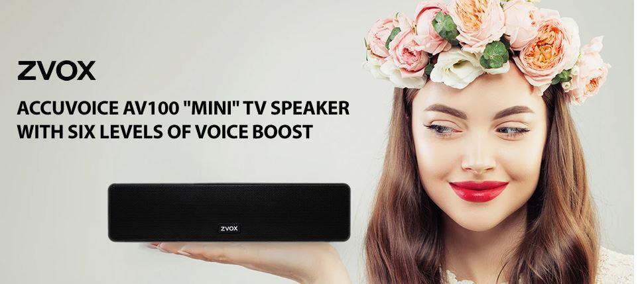

I've never seen this feature on any other device, but it may become more popular as users realize that such a device is available.

The kit also has several connectors. Only one is used, but you must refer to the brief manual to determine which one to use to connect to your TV set. I had some trouble with this and had to call their support to get the job done. Support was extremely helpful and very patient.

The soundbar includes its own speakers, which are a bit better than my TV's speakers.

My Dish remote turns on both my TV and the Dish controller. The ZVOX's remote turns on the soundbar. Two LEDs let you know what the status is. One is blue, which indicates power on, volume down, or mute, and the other is amber, which indicates volume up. When you push Accuvoice, the blue LED shows briefly.

A standard power cord and plug power the soundbar. The sound bar's dimensions are 10" X 2.5" X 3".

The company provides free shipping and a 60-day free home trial. In addition, the product has a one-year parts and labor warranty.

I'm very satisfied with this product. It provides a measure of relief for those situations where the program's voice is nearly unintelligible because of the overriding music or other background sound.

ACCUVOICE AV100 "MINI" TV SPEAKER

https://zvox.com/collections/accuvoice/products/av100-accuvoice-speaker

Price $100

